**CSC3400**

**DATABASE PRINCIPLES**

**DATABASE MANAGEMENT SYSTEM ENVIRONMENT**

**SECOND SEMESTER 2024/2025**

**WEEK 1**

**Learning Outcome:**

* **to get familiar with the DBMS environment**
* **to install SQL Developer client on students machine**
* **to access Oracle remotely**

There are 2 ways to access Oracle Server in FSKTM

1. From Makmal Perdana or Makmal Kejuruteraan Perisian 2 (via VDi client)
2. From your own notebook (you need to download and install SQL Developer Client v20.4)

**A: Accessing Oracle Server from Makmal Perdana or Makmal Kejuruteraan Perisian 2**

1. Log in to VDi client using UPMID

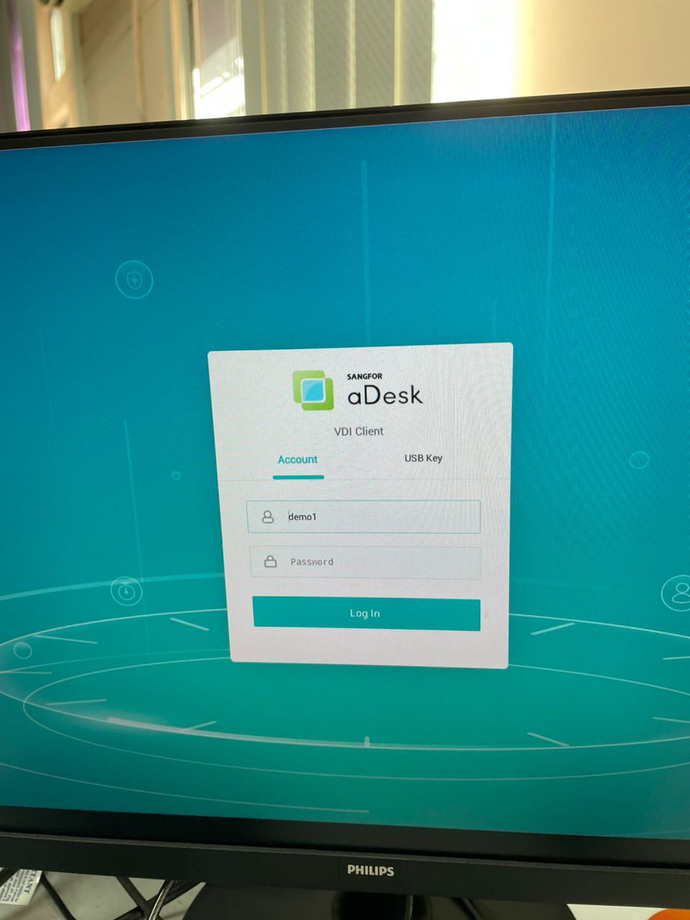

1. Choose your database (student_database_fsktm)

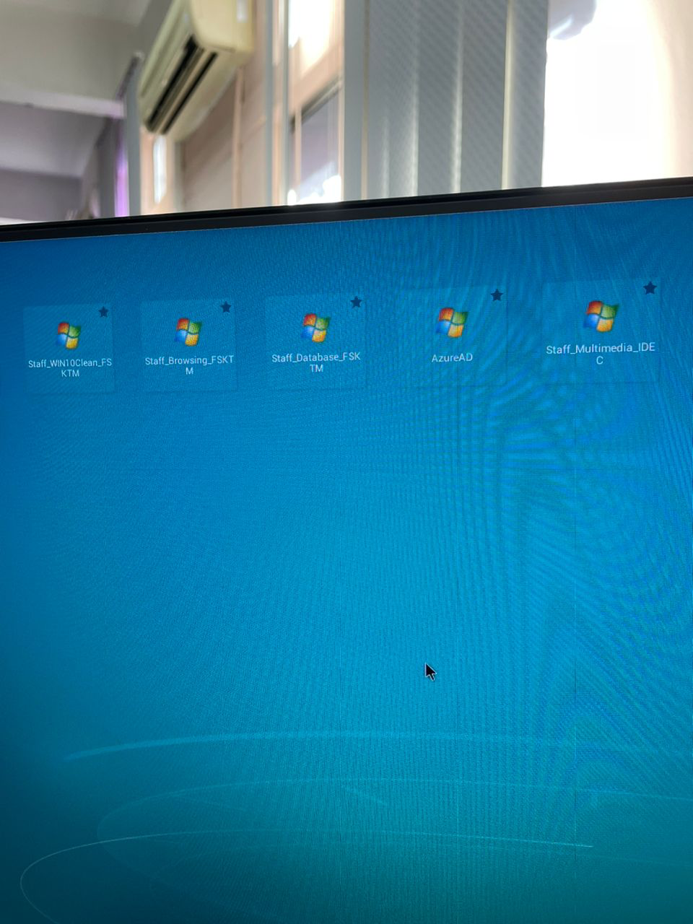 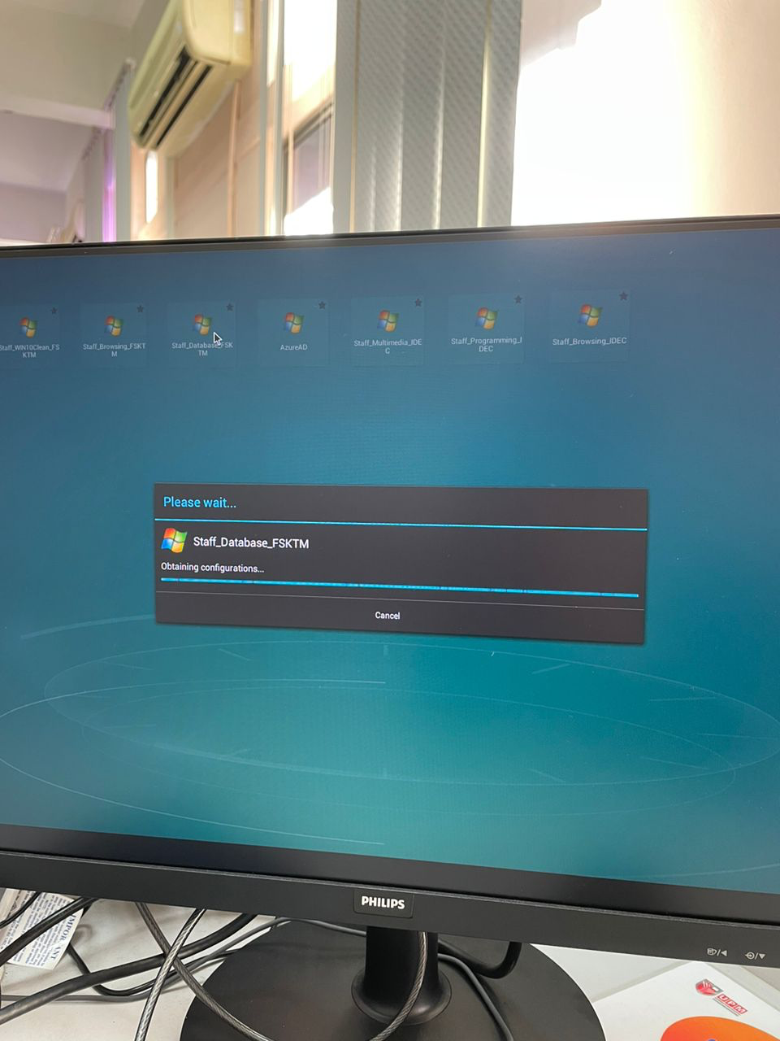

1. Double click SQL Developer

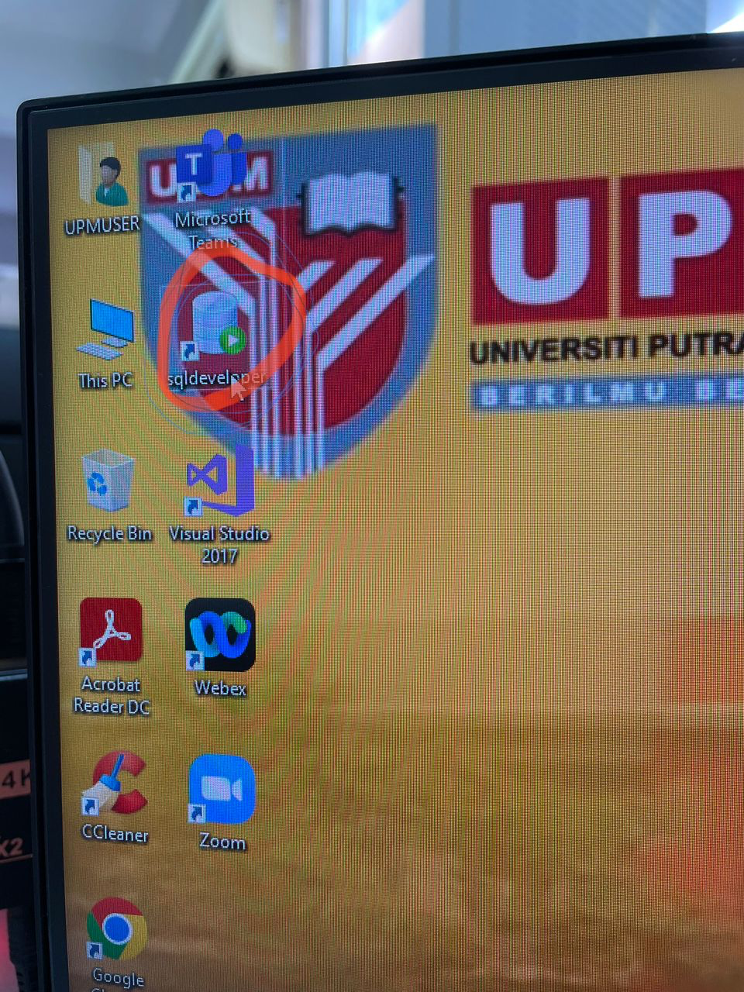 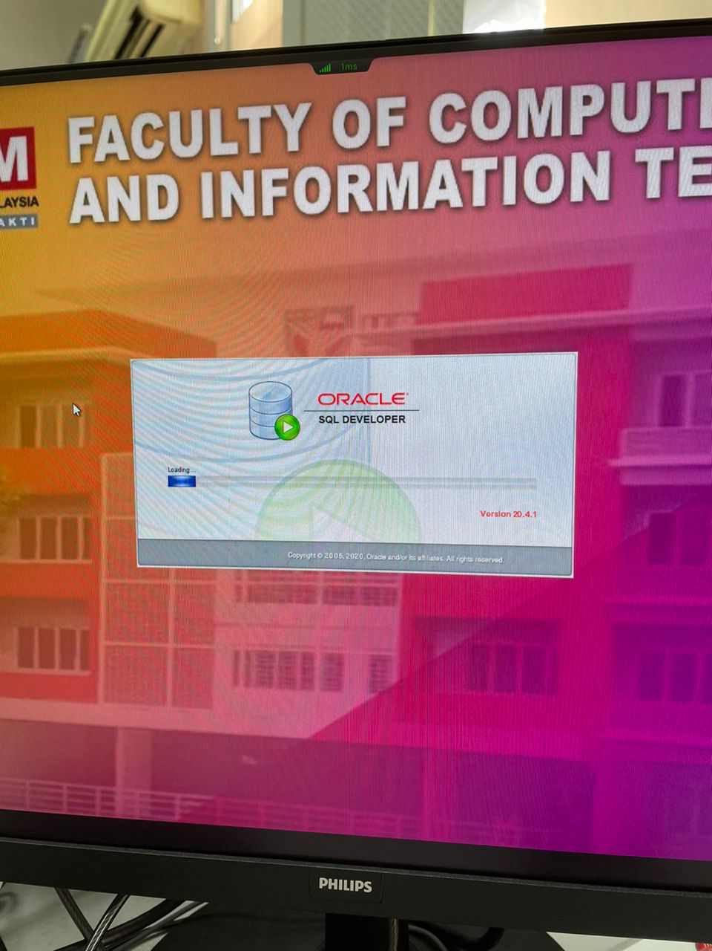

1. Choose oracle_fsktm connection

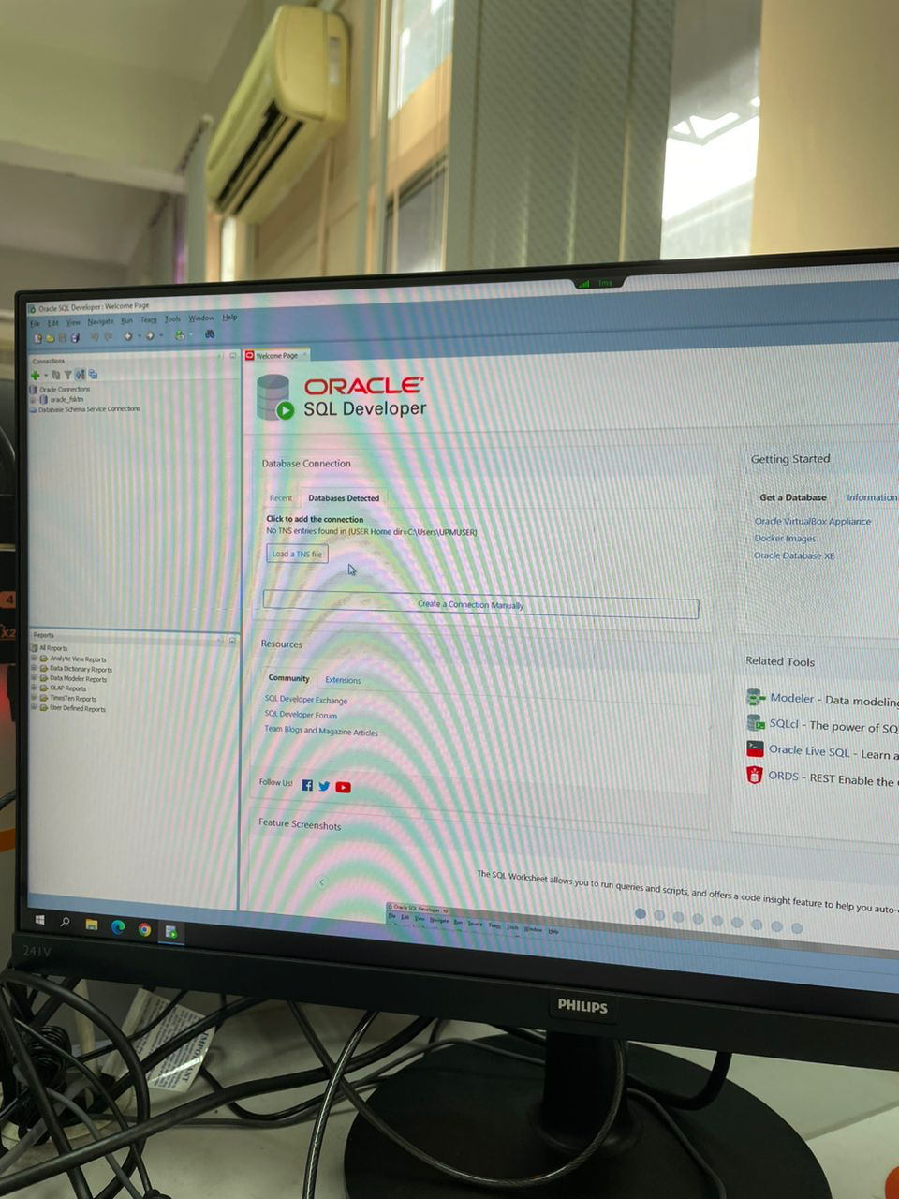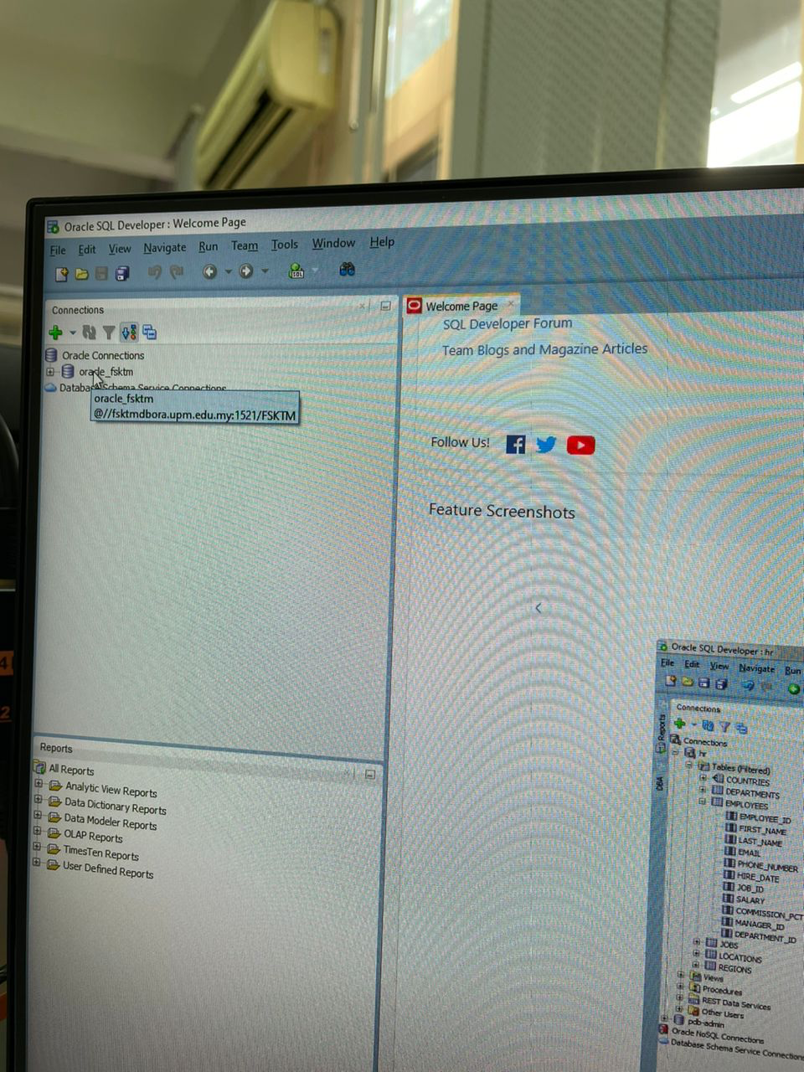

1. Log in using your Oracle account credential

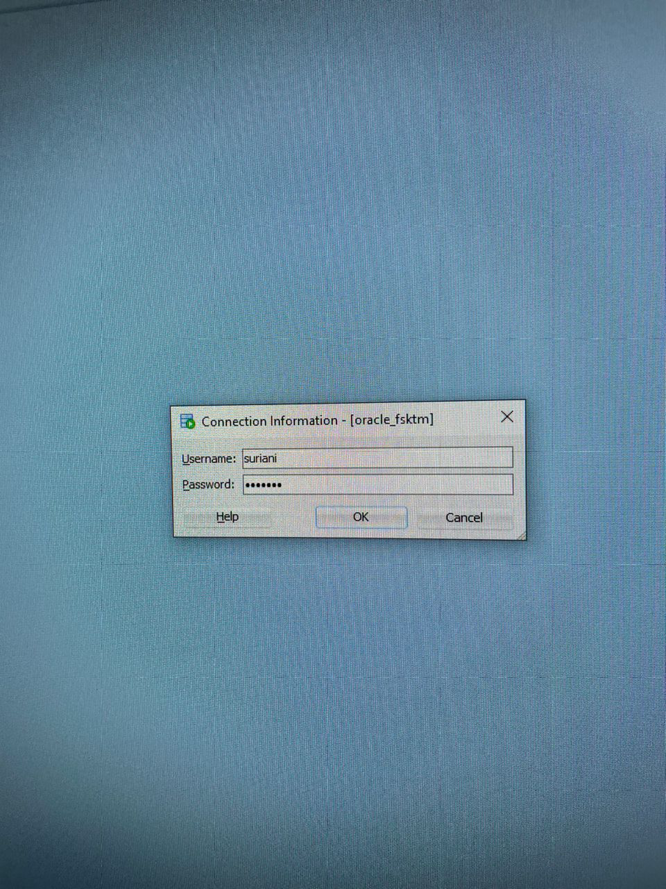

**Please use your own matric number**

## for group 2, if your matric number is 123456,

then your username: B123456, password: 123456

1. You should be able to see your tables etc.

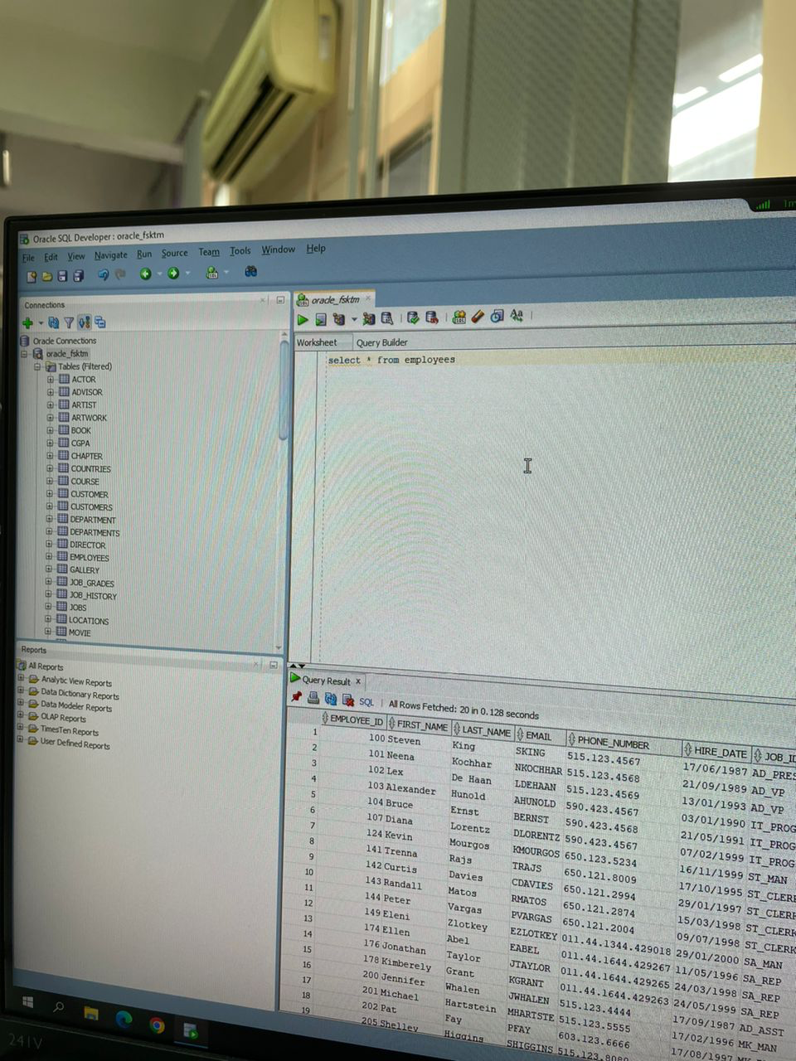

1. To exit don’t forget to **shut down** and then **logout** from VDi

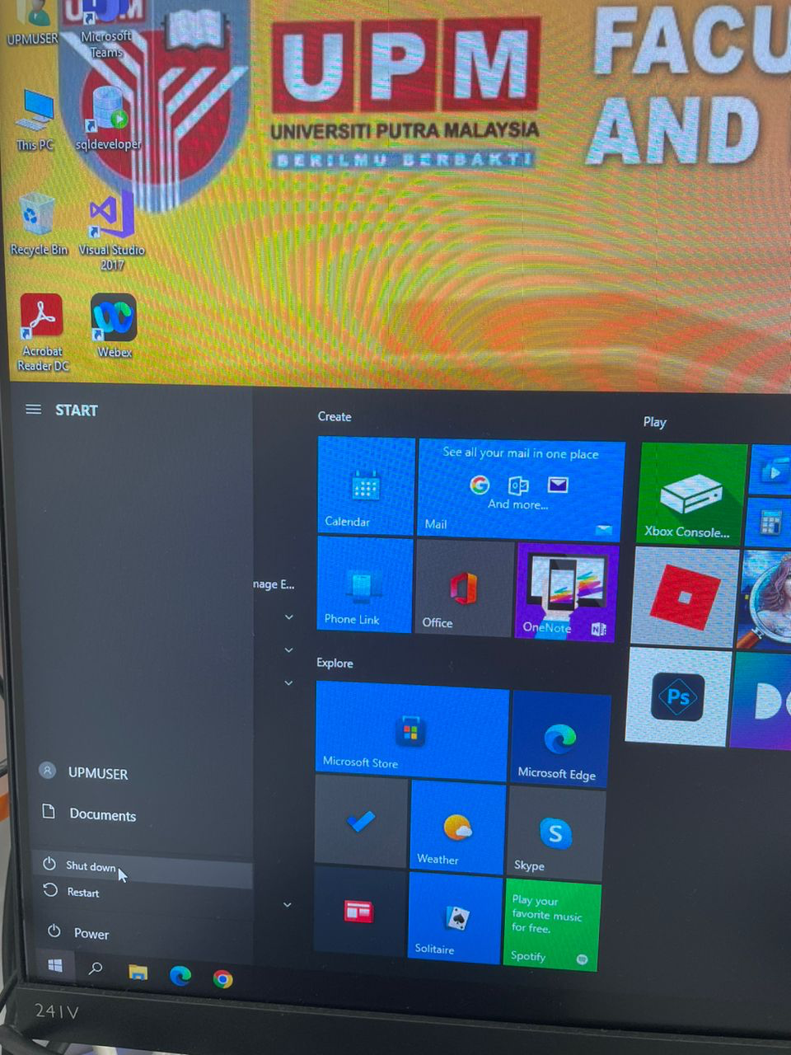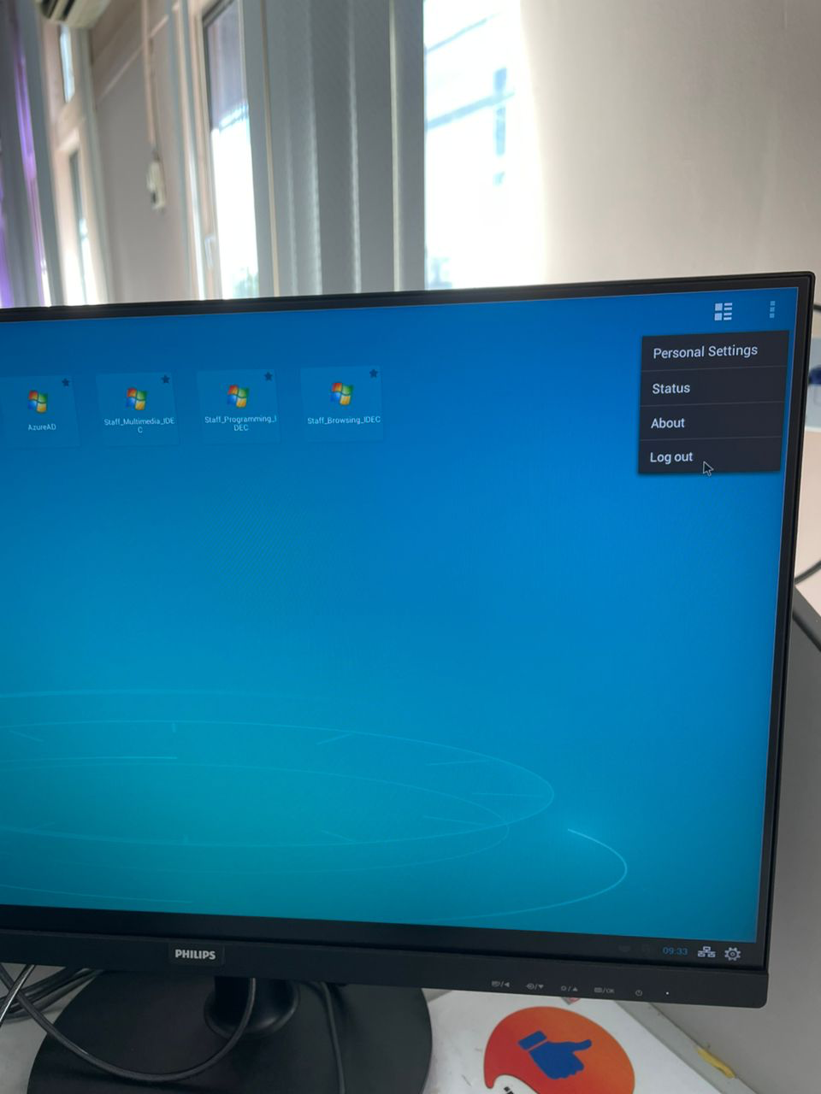

**B: Accessing Oracle Server from your own notebook**

1. First you need to download and install SQL Developer (version 20.4) depending on your OS
2. FSKTM shall create Oracle accounts for students using matric number (normally the username would be X123456, where X is an alphabet (A-J) depending on the total number of group, and the password is the matric number (eg. 123456),

## so for group 2 if your matric number is 123456, then username is B123456; your password is 123456.

1. Launch SQL Developer and create a new database connection as follows:
   1. Hostname: fsktmdbora.upm.edu.my
   2. Port:1521
   3. SID: fsktm
2. Test the connection using your own Oracle account credentials, if successful then click Connect.